

**HCSB*Romans 1:16-17—16*** *I am not ashamed of the gospel, because it is the power of God for the salvation of everyone who believes: first for the Jew, then for the Gentile. 17 For in the gospel a righteousness from God is revealed, a righteousness that is by faith from first to last, just as it is written: “The righteous will live by faith.”*

**The gospel message is _____________________.**

* It is ________________________ in message.
* It is a ________________________ message.

**The gospel message is _____________________.**

* The gospel is for the ____________________.
* The gospel is for the ____________________.

**The gospel message is _____________________.**

* The gospel reveals _____________________.
* The gospel reveals _____________________.



**HCSB*Romans 1:16-17—16*** *I am not ashamed of the gospel, because it is the power of God for the salvation of everyone who believes: first for the Jew, then for the Gentile. 17 For in the gospel a righteousness from God is revealed, a righteousness that is by faith from first to last, just as it is written: “The righteous will live by faith.”*

**The gospel message is _____________________.**

* It is ________________________ in message.
* It is a ________________________ message.

**The gospel message is _____________________.**

* The gospel is for the ____________________.
* The gospel is for the ____________________.

**The gospel message is _____________________.**

* The gospel reveals _____________________.
* The gospel reveals _____________________.



**HCSB*Romans 1:16-17—16*** *I am not ashamed of the gospel, because it is the power of God for the salvation of everyone who believes: first for the Jew, then for the Gentile. 17 For in the gospel a righteousness from God is revealed, a righteousness that is by faith from first to last, just as it is written: “The righteous will live by faith.”*

**The gospel message is _____________________.**

* It is ________________________ in message.
* It is a ________________________ message.

**The gospel message is _____________________.**

* The gospel is for the ____________________.
* The gospel is for the ____________________.

**The gospel message is _____________________.**

* The gospel reveals _____________________.
* The gospel reveals _____________________.

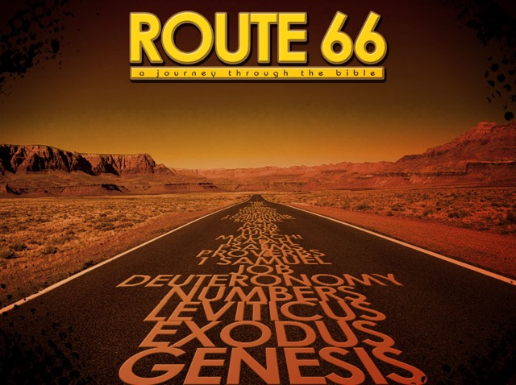

**Wednesday, March 1**

**AM**

8:00 Cradles 2 Crayons

Setup

8:30 Office Open

**PM**

12:00 Noon Bible Study

3:30-5:00 Baby Closet Open

5:30 NO AWANA Meal

6:00 NO AWANA

6:00 NO Youth Bible Study

7:00 NO Choir Practice

**Thursday, March 2**

**AM**

8:30-5:00 Office Open

9:00 3R’s Senior Group

**PM**

7:00 Cradles 2 Crayons

**Friday, March 3**

**AM**

8:30-5:00 Office Open

11:00 Cradles 2 Crayons

**PM**

**Wednesday, March 1**

**AM**

8:00 Cradles 2 Crayons

Setup

8:30 Office Open

**PM**

12:00 Noon Bible Study

3:30-5:00 Baby Closet Open

5:30 NO AWANA Meal

6:00 NO AWANA

6:00 NO Youth Bible Study

7:00 NO Choir Practice

**Thursday, March 2**

**AM**

8:30-5:00 Office Open

9:00 3R’s Senior Group

**PM**

7:00 Cradles 2 Crayons

**Friday, March 3**

**AM**

8:30-5:00 Office Open

11:00 Cradles 2 Crayons

**PM**

Weekly Schedule

**Sunday, February 26**

**AM**

9:30 Life Groups

10:45 Morning Worship

**PM**

12:00 Missions Lunch

5:00 Evening Worship

**Monday, February 27**

**AM**

8:30-5:00 Office Open

10:30-12:00 Bible Study

*(Meeting in Fellowship Hall)*

**PM**

8:00 University Bible Study

**Tuesday, February 28**

**AM**

8:30-5:00 Office open

**PM**

1:00-3:00 Baby Closet Open

**Wednesday, March 1**

**AM**

8:00 Cradles 2 Crayons

Setup

8:30 Office Open

**PM**

12:00 Noon Bible Study

3:30-5:00 Baby Closet Open

5:30 NO AWANA Meal

6:00 NO AWANA

6:00 NO Youth Bible Study

7:00 NO Choir Practice

**Thursday, March 2**

**AM**

8:30-5:00 Office Open

9:00 3R’s Senior Group

**PM**

7:00 Cradles 2 Crayons

**Friday, March 3**

**AM**

8:30-5:00 Office Open

11:00 Cradles 2 Crayons

**PM**

*For God did not give us a spirit of timidity, but a spirit of power, of love and of self-discipline. So do not be ashamed to testify about our Lord…*

**2 Timothy 1:7-8a**

*For God did not give us a spirit of timidity, but a spirit of power, of love and of self-discipline. So do not be ashamed to testify about our Lord…*

**2 Timothy 1:7-8a**

**Sunday, February 26**

**AM**

9:30 Life Groups

10:45 Morning Worship

**PM**

12:00 Missions Lunch

5:00 Evening Worship

**Monday, February 27**

**AM**

8:30-5:00 Office Open

10:30-12:00 Bible Study

*(Meeting in Fellowship Hall)*

**PM**

8:00 University Bible Study

**Tuesday, February 28**

**AM**

8:30-5:00 Office open

**PM**

1:00-3:00 Baby Closet Open

**Sunday, February 26**

**AM**

9:30 Life Groups

10:45 Morning Worship

**PM**

12:00 Missions Lunch

5:00 Evening Worship

**Monday, February 27**

**AM**

8:30-5:00 Office Open

10:30-12:00 Bible Study

*(Meeting in Fellowship Hall)*

**PM**

8:00 University Bible Study

**Tuesday, February 28**

**AM**

8:30-5:00 Office open

**PM**

1:00-3:00 Baby Closet Open

*For God did not give us a spirit of timidity, but a spirit of power, of love and of self-discipline. So do not be ashamed to testify about our Lord…*

**2 Timothy 1:7-8a**

Weekly Schedule

Weekly Schedule

**John** **, 18 (HCSB)—***1In the beginning was the Word, and the Word was with God, and the Word was God. 2He was with God in the beginning. 3All things were created through Him, and apart from Him not one thing was created that has been created. 18No one has ever seen God. The One who is at the Father’s side—He has revealed Him.*